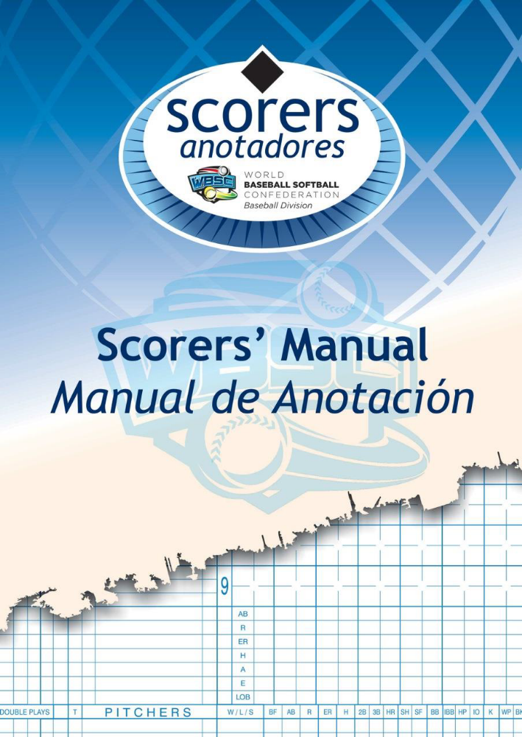

Baseball Scorers’ Manual

English version - 2016

Copyright © 2015-2020 Anna Maria Paini as President of Italian Scorers

All rights reserved.
Without limiting the rights under copyright reserved above, no part
of this publication may be reproduced, stored in or introduced into
a retrieval system, or transmitted, in any form or by any means
(electronic, mechanical, photocopying, recording or otherwise),
without the prior written permission of both the copyright owner
and the above publisher of this book.

Published and distributed by WBSC – Baseball Division under
courtesy and permission of Anna Maria Paini (President of Italian
Scorers)

Written by: G. Bianchi (Ita), M. Fratticci (Ita), AM. Paini (Ita)
Revision 2016 by: P. Carpio (Esp), AM. Paini (Ita), L. Steijger (Ned)
Acknowledgments

I’d like to start with a thank you to Giancarlo Bianchi and Mario Fratticci, not only for their work, but also because they knew baseball and its rules so well and they passed their knowledge to me.

There are other people who helped tremendously and at the top of the list there are Linda Steijger and Pablo Carpio: Linda is so insightful and she has done so much inthe last three years and Pablo generously took time away from his job and family in the true spirit of friendship and passion, he never hesitated to point out the spots where he thought we have to make something clearer. Our meetings always ended with a last-minute reminder to add a word, a paragraph, and Linda had to change the pages again.

Thanks to Don Darling (CAN), Jenny Moloney (AUS), Susana Santos (ESP), the Italian Scorers Technical Commission (Marco Battistella, Osvaldo Faraone, Stefano Pieri, Maurizio Ronchi and Marco Travagli) and the Copabe Friends [Andres De Leon (PAN), Carlos Del Pino (CUB), Oscar Izaguirre (VEN)]: they gave us a lot of suggestions.

Anna Maria Paini
Scoring Commission Chair

September 2016

Foreword

The art and importance of scorekeeping is one of baseball’s fundamental pillars, which tracks and enters each pitch and play into the official record – providing the foundation for the birth of many statistics and analyses that are closely bound to the sport of baseball, and help shape the competition itself. It is the scorer’s chief task to accurately and objectively interpret and transcribe the game’s results on the field.

Scorekeeping and statistics are perhaps greater tied to baseball than to any other sport, and they are the basis not only for the players, managers and teams to evaluate and compare performance and to predict tendencies, which help form strategies, but scoring and statistics also form a large part of the fan-experience that makes the sport of baseball unique.

This Scoring Manual will remain a powerful resource to standardize the procedure of universally recording the game of baseball. As the sport of baseball continues to break ground into new territories, reliance on such a manual will only increase and help promote the integrity of our sport – ensuring that a particular play will be recorded the same across the globe.

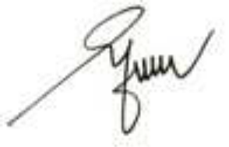
Riccardo Fraccari
President
World Baseball Softball Confederation

Sommaire
The Scorekeeper 13
Preface 15
Le scoreur 16
Preface 17
Chapitre 1 - La feuille officielle de scorage. 18
Symboles et abréviations. 18
La feuille de scorage officielle 18
L’entête de la première feuille. 18
L’entête de la seconde feuille. 18
Lineup (Ordre au bâton). 18
La section centrale. 18
Zone défense. 18
Zone offensive. 18
Performance du lanceur. 18
Performance des receveurs. 18
Zone de contrôle. 18
Compléter les tables. 18
Pas assez de place sur la feuille de scorage. 18
Chapitre 2 - la défense. 19
Les retraits. 19
Retrait d’un batteur. 19
Retrait d’un coureur. 19
Double jeu et triple jeu. 19
Retrait automatique prévu par le règlement (‘OBR’). 19
Jeux d’appel. 19
Jeux d’appel contre des batteurs qui ont frappé un double, un triple ou un home run. 19
Retrait sur ‘Infield fly’. 19
Batteur qui ne respecte l’ordre à la batte. 19
Les assistances. 19
Les erreurs. 19
Les erreurs décisives. 19
Les erreurs non décisives. 19
Interférence et obstruction. 19
Exemple d’erreurs sur la feuille de scorage. 20
Erreurs exemptées. 20
Chapitre 3 – l’attaque. 21
Les hits. 21
Déterminer la valeur d’un hit. 21
Les hits de fin de jeu. 21
Conclusion finale sur les hits. 21
Les sacrifices. 21
Sacrifice hits, sacrifice bunts. 21
Sacrifice fly. 21
Arrivée safe en première base. 21
Base on ball. 21
Le base on ball intentionnel. 21
Le Hit by pitch. 21
L’interférence défensive. 21
L’obstruction. 21
Avance en première base quand la balle touche un coureur ou l’arbitre. 21
Les avances. 22
L’avance sur un hit. 22
L’avance sur un retrait. 22
L’avance sur une erreur. 22
L’avance sur une interférence. 22
L’avance sur une obstruction. 22
Les autres avances. 22
Le balk. 22
Le lancer fou. 22
La balle passée. 22
Les choix défensifs. 22
La balle occupée. 22
L’indifférence, choix défensif pour un retrait sur tentative vol. 22
Le choix défensif. 22
Une relance. 22
Les bases volées 23
Retrait sur tentative de vol. 23
Avances particulières. 23
Balles logées dans le masque ou le matériel de l’arbitre ou du receveur. 23
Lancer qui touche un coureur tentant de marquer un point. 23
Lancer qui touche un coureur dans la zone des Strikes quand il tente de marquer un point. 23
Un joueur défensif, après avoir attrapé une ‘fly’, tombe sur un banc ou un stand, ou dans une foule avec des spectateurs sur le terrain. 23
Un ‘Infield fly’ manqué. 23
Le point produit. 23
Chapitre 4 – Les remplacements. 24
Les remplacements. 24
Changements internes. 24
Changements dans l’ordre à la batte. 24
Un lanceur replaçant un ‘DH’ à l’attaque. 24
Un DH devenant défenseur. 24
Remplacement de coureurs. 24
Remplacement de lanceurs. 24
Remplacement d’un batteur avant qu’il ne finisse son tour à la batte. 24
Remplacement d’un lanceur avec un batteur au bâton. 24
Chapitre 5 – Le lanceur. 25
Les points mérités. 25
Quand un point ne peut jamais être mérité. 25
Quand un point peut devenir mérité. 25
Changement de lanceur et points mérités. 25
Crédit des lanceurs. 25
Le lanceur gagnant. 25
Le lanceur perdant. 25
Le lanceur de sauvegarde. 25
Le point produit gagnant. 25
Chapitre 6 – divers. 26
Times at bat. 26
Frappeur désigné. 26
Protestation. 26
Match suspendu. 26
Match forfait. 26
Match terminé sur une différence de point. 26
Les statistiques. 26

The Scorekeeper

Rule 9.01(c) of the Official Baseball Rules (OBR) states: The official scorer is an official representative of the World Baseball Softball Confederation (WBSC) – Baseball Division, and is entitled to the respect and dignity of his office, and shall be accorded full protection by the WBSC Baseball Division. The official scorer shall report to the WBSC Baseball Division Tournament Director or WBSC Baseball Division Headquarter any indignity expressed by any manager, player, team employee or team officer in the course of, or as the result of, the discharge of official scorer duties.

Rule 9.01(a) of the OBR states: The Scoring Director shall appoint an official scorer for each championship game. The official scorer shall observe the game from an appropriate position (in order to ensure that he does his job properly, he must be in the best position, possibly an elevated one, where the public does not have free access. He may take position in the press box, where such exists). The official scorer shall have sole authority to make all decisions concerning application of Rule 9 that involve judgment, such as whether a batter’s advance to first base is the result of a hit or an error. The official scorer shall communicate such decisions to the press box and broadcasting booths by hand signals or over the press box loudspeaker system and shall advise the public address announcer of such decisions if requested.

The official scorer shall make all decisions concerning judgment calls within 15 minutes after a game concludes or is suspended. No judgment decision shall be changed thereafter except, upon immediate application to the WBSC Baseball Division, the scorer may request a change, citing the reasons for such. In all cases, the official scorer is not permitted to make a scoring decision which is in conflict with the scoring rules (according to rule 9.01).

After each game, including forfeited and called games, the official scorer shall prepare a report (the score-sheet), on a form prescribed by the WBSC Baseball Division rules. He shall forward this report to the Scoring Director of the tournament at the end of each game.

According to rule 9.01(b) of the OBR: in all cases, the official scorer shall not make a scoring decision that is in conflict with Rule 9 or any other Official Baseball Rules, WBSC Baseball Division Scoring Rules or with an umpire’s decision. If the teams change sides before three men are put out, the official scorer shall immediately inform the umpire-in-chief of the mistake. If the game is protested or suspended, the official scorer shall make a note of the exact situation at the time of the protest or suspension, including the score, the number of outs, the position of any runners, the ball-and-strike count on the batter, the lineups of both teams and the players who have been removed from the game for each team. This is very important as, if a protested or suspended game is ordered replayed, the game must be resumed with exactly the situation that existed just before the protested play. The official scorer shall not call the attention of any umpire or of any member of either team to the fact that a player is batting out of turn.
The umpire-in-chief shall ensure, particularly in the case of runs scored concurrently with the third putout (rundown plays, appeal plays, etc), that he indicates clearly to the official scorer the legality or otherwise of the run.
In addition to the provisions of this manual, the official scorer should be familiar with the Official Baseball Rules (OBR), in particular rule 9.00.

Preface

This scorers’ manual has been prepared to provide the necessary information for recording plays and thereby determining the score of a baseball game.
It begins with the symbols and abbreviations used to record the actions of the game.
For clarity, paragraphs taken in their entirety from the Official Baseball Rules appear in italic script throughout the manual.
Any reference in this Scorers’ Manual to “he”, “him” or “his” shall be deemed to be a reference to “she”, “her” or “hers” as the case may be when the person is a female.

